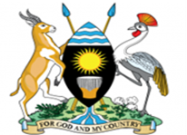
National Population Council
Competition to design 2019 World Population Day Logo
Every year on July 11, Uganda joins the rest of the world to commemorate World Population Day. This day is used to highlight population and development issues affecting the country and key strategic interventions. The National Population Council which is mandated to oversee the country’s population programme is organizing activities to commemorate World Population Day. This year’s celebrations will be held in Adjumani district under the theme: “Renewing the Promise: Empowering Uganda’s Youth to drive Socio – Economic Transformation”. The National Population Council is appealing to graphic designers, artists’ to enter a competition to design a logo that best illustrates the theme. The winning artist will receive two million (Ug Shs. 2,000,000) Uganda shillings.
Please submit 3 of your best logos to National Population Council, email: npcsec@npcsec.go.ug not later than 29th, May 2019 at 4.30pm. Attention: Ms. Stella Kigozi, Director Information & Communication Department

